

International School

**Capstone Project 1**

CMU-SE 450/CMU-IS 450/CMU-CS450

**Project Product Backlog**

**Version 1.1**

**Date: September 14, 2020**

**UNIVERSITY REVIEWS**

**Submitted by**

**Nguyen Van Minh Toi**

**Nguyen Huu Thien**

**Ho Xuan Sang**

**Huynh Thi Quy Thuong**

**Approved by**

**Product Backlog Review Panel Representative:**

Name Signature Date

**Capstone Project 1- Mentor:**

Name Signature Date

**Dr.Ha Thi Nhu Hang**

**PROJECT INFORMATION**

|  |  |  |  |
| --- | --- | --- | --- |
| Project acronym | URs | | |
| Project Title | University reviews | | |
| Start Date | August 13, 2020 | End Date | December 05, 2020 |
| Lead Institution | International School, Duy Tan University | | |
| Project Mentor &contact details | Dr. Ha Thi Nhu Hang  Email: [hatnhuhang@duytan.edu.vn](mailto:hatnhuhang@duytan.edu.vn)  Tel: 0707121301 | | |
| Product Owner | Toi, Nguyen Van Minh  Email: [minhtoi2799@gmail.com](mailto:minhtoi2799@gmail.com)  Tel: 0902257132 | | |
| Scrum Master | Thien, Nguyen Huu  Email: [huuthiennguyen1999@gmail.com](mailto:huuthiennguyen1999@gmail.com)  Tel: 0783533812 | | |
| Team members | Name | Email | Tel |
| Toi, Nguyen Van Minh | minhtoi2799@gmail.com | 0902257132 |
| Thien, Nguyen Huu | huuthiennguyen1999@gmail.com | 0783533812 |
| Sang, Ho Xuan | hsang19999@gmail.com | 0362982905 |
|  | Thuong, Huynh Thi Quy | quythuong0405@gmail.com | 0333633770 |

|  |  |  |  |
| --- | --- | --- | --- |
| **DOCUMENT NAME** | | | |
| **Document Title** | Management System Product Backlog Document | | |
| **Author(s)** | Nguyen Van Minh Toi | | |
| **Role** | Team Member | | |
| **Date** | 14 – September –2020 | **File name:** | Product Backlog ver 1.1 |
| **URL** |  | | |
| **Access** |  | | |

|  |  |  |  |
| --- | --- | --- | --- |
| **REVISION HISTORY** | | | |
| **Version** | **Person** | **Date** | **Description** |
| **1.0** | Nguyen Van Minh Toi | 06 – September –2020 | Draft |
| **1.1** | Nguyen Van Minh Toi  Nguyen Huu Thien | 14 – September –2020 | Update Product Backlog. |

|  |  |  |  |
| --- | --- | --- | --- |
| **Document Approval**  The following signatures are required for approval of this document | | | |
| **Mentor** | Dr. Ha Thi Nhu Hang | **Signature:** |  |
| **Date:** |  |
| **Scrum Master** | Nguyen Huu Thien | **Signature:** |  |
| **Date:** |  |
| **Team Member(s)** | Ho Xuan Sang | **Signature:** |  |
| **Date:** |  |
| Nguyen Van Minh toi | **Signature:** |  |
| **Date:** |  |
| Huynh Thi Quy Thuong | **Signature:** |  |
| **Date:** |  |

Contents

**1.** **Introduction:** 5

**1.1.** **Purpose:** 5

**1.2.** **Scope:** 5

**1.3.** **References:** 5

**2.** **Product Backlog:** 6

**2.1.** **Product Backlog Items Diagram** 6

**2.2.** **Product Backlog Specification** 7

**2.3.** **Analysis Sprint Backlog:** 11

**3.** **Constraint:** 11

**4.** **Stakeholders and User Descriptions Summary:** 12

1. **Introduction:**
   1. **Purpose:**

* Provide a prioritized features list, containing short description of all functionality desired in the product.
* Provide a prioritized features constraint list.
  1. **Scope:**
* Lists the management system’s module role.
* Lists some main function of system manager.
* Short description of all the functionality desired in the product.
* Given the priority of each feature and function of the product.
  1. **References:**

***Table 1: References***

|  |  |  |
| --- | --- | --- |
| **No** | **Reference** | **Note** |
| 1 | <http://agilebench.com/blog/the-product-backlog-for-agile-teams> | How to create product backlog |
| 2 | <http://www.mountaingoatsoftware.com/agile/scrum/product-backlog/example/> | Product Backlog Example |

1. **Product Backlog:**
   1. **Product Backlog Items Diagram**

Module Management System:

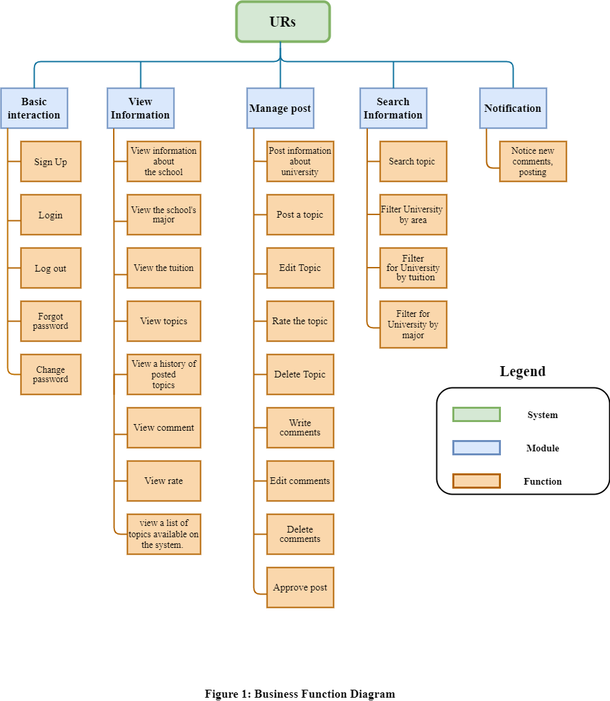

***Figure 1: Management System*** ***Diagram***

* 1. **Product Backlog Specification**

***Table 1: Management System*** ***Specification (User)***

|  |  |  |  |  |
| --- | --- | --- | --- | --- |
| **ID** | **As a/an** | **I want to** | **So that** | **Priority** |
| PB 1 | User | Sign Up | I can register a new account to log in to the system (except for the Administrator account). | 1 |
| PB 2 | User | Log in | I can log in to the system with my account. | 1 |
| PB 3 | User | Change password | I can change my password if I want. | 4 |
| PB 4 | User | Login to the system with Facebook. | I can log in with my Facebook account | 1 |
| PB 5 | User | Edit personal information | I can correct my personal information when there is a change in my information | 4 |
| PB 6 | User | Log out | I can log out when not using the system | 1 |
| PB 7 | User | Forgot password | Can I retrieve my password if I don't remember .. | 4 |
| PB 8 | User | Filter for schools by major | I can view the school by filtered by major | 2 |
| PB 9 | User | Filter schools by area | I can view the school by filtered by area | 2 |
| PB 10 | User | Filter for schools by tuition | I can view the school by filtered by tuition | 2 |
| PB 11 | User | View information about the school | I can view introductory information about the school | 3 |
| PB 12 | User | View the school's major | I can view the school's major information | 3 |
| PB 13 | User | View the tuition | I can view the school's tuition information | 3 |
| PB 14 | User | Rate the school | I can rate the school | 2 |
| PB 15 | User | View topics | I can view the most read topics | 2 |
| PB 16 | User | Search and view a list of topics available on the system. | I can view the list and search all the posts that have been posted to the system. | 3 |
| PB 17 | User | Write comments | I can comment on the topic | 2 |
| PB 18 | User | Edit comments | I can edit the comment to match the topic | 2 |
| PB 19 | User | Delete comments | I can delete a comment so that people won't see it | 2 |
| PB 20 | User | Rate the topic | I can rate the topic from 1-5 stars | 2 |
| PB 21 | User | Post a topic | I can post topics to answer questions | 2 |
| PB 22 | User | Edit Topic | I can edit the topic to match the topic | 2 |
| PB 23 | User | Delete Topic | I can delete a topic so that people won't see it | 2 |
| PB 24 | User | View notifications | I can see the notice when other users comment or rate a topic | 4 |
| PB 25 | User | View a history of posted topics | I can see the history of the topics posted. | 4 |

***Table 2: Management System*** ***Specification (University)***

|  |  |  |  |  |
| --- | --- | --- | --- | --- |
| **ID** | **As a/an** | **I want to** | **So that** | **Priority** |
| PB26 | University | Access to the system by my account | I must input username on [Username] field and password on [Password] field and then click on [Log in] button to use system. | 3 |
| PB27 | University | Log out system | I can stop using system when I click on [Log out] button and I can log in later when I want to use system on next time. | 3 |
| PB28 | University | Change my password regularly | I can keep it secure or make it easier to remember. | 4 |
| PB29 | University | Post information to my university | I can give detailed information about the university | 3 |
| PB30 | University | Update information | I can add, edit, and delete information about the university | 3 |
| PB31 | University | Views topics | Views topics about my University by users who talk about my university | 3 |
| PB32 | University | View comment | Views comments about my University | 3 |
| PB33 | University | View rate | Views rate by users who rated about my university. | 3 |
| PB34 | University | View notification | views notification about topic, comment, rate | 3 |

***Table 3: Management System*** ***Specification (***Administrator***)***

|  |  |  |  |  |
| --- | --- | --- | --- | --- |
| **ID** | **As a/an** | **I want to** | **So that** | **Priority** |
| PB 35 | Administrator | Login system | I can log in to the system with my account. | 3 |
| PB 36 | Administrator | Logout system | I can log out of the system if I want to. | 3 |
| PB 37 | Administrator | Change password | I can change my account password if I want. | 4 |
| PB 38 | Administrator | See all information, content | I can view all information and content on the system. | 1 |
| PB 39 | Administrator | Approve post | I can view and approve posted by users or representatives of the University. To see if the post has been shown to the system? | 2 |
| PB 40 | Administrator | Manage users | I can manage all users in the system. If detecting a violation, the user account can be locked and reopened (if desired). | 1 |
| PB 41 | Administrator | Manage reviews and breaches | I can manage all user reviews on the system; It is also possible to manage breaches to give warnings to users when needed. | 1 |

* 1. **Analysis Sprint Backlog:**

|  |  |  |  |  |  |
| --- | --- | --- | --- | --- | --- |
| **STT** | **Stage** | **Iteration** | **User story** | **Start day** | **End date** |
| 1 | Initial | STU |  | 13-August-20 | 18-August-20 |
| 2 | Development | **SPR1** | PB1, PB2, PB4, PB38,PB6, PB40, PB41 | 29- August -20 | 25-September-20 |
| **SPR2** | PB8, PB9, PB10, PB15, PB17, PB18, PB19, PB20, PB21, PB22, PB23, PB39 | 25- September -20 | 22-October-20 |
| **SPR3** | PB11, PB12, PB13, PB14, PB16, PB26, PB27, PB29, PB30, PB31, PB32, PB33, PB34, PB35, PB36 | 22- October -20 | 11- November 20 |
| **SPR4** | PB3, PB5, PB7, PB24, PB25, PB28, PB37 | 11- November -20 | 01- December -20 |
| 3 | Project completion | FRE |  | 03-December-20 | 04- December -20 |

1. **Constraint:**

***Table 4: Constraint***

|  |  |
| --- | --- |
| **Constraint** | **Condition** |
| **Time** | Project must on time with schedule. |
| **People constraint** | 4 people working together to finish the project |
| **The integrated system** | Must be connected with the Internet network to operate. |
| **Requirements** | According to Product owner’s Requirements |

1. **Stakeholders and User Descriptions Summary:**

***Table 5: Stakeholders and User Descriptions Summary***

|  |  |  |
| --- | --- | --- |
| **Name** | **Description** | **Role** |
| **Product Owner** | The Person who give the Requirement | Provide information to develop the system. Make the decision to accept and implement the project, do the unit test |
| **Scrum Master** | This is the stakeholder who leading, manage the system development Team | Controlling, managing, monitoring, make sure the project complete on time, within budget, according to plan and according to requirements |
| **Requirement Analyzer** | This is a stakeholder that works with the Analysts to correctly translate requests or needs into requirements to be used for design | Specifies the details of one or more a parts of the system’s functionality by describing one or the aspects of the requirements,  This will include functional and non-functional |
| **Software Architect** | This is a stakeholder that is primary for leading the system development | Responsible for the software architecture, which includes the key technical decisions that constrain the overall design for the project |
| **Coder** | This is a stakeholder that programs the software | Implement the project |